**Московский авиационный институт**

**(Национальный исследовательский университет)**

Институт: «Информационные технологии и прикладная математика»

Кафедра: 806 «Вычислительная математика и программирование»

Дисциплина: «Компьютерная графика»

**Лабораторная работа № 7**

Тема: Построение плоских полиномиальных кривых.

Студент: Лошманов Юрий Андреевич

Группа: 80-306

Преподаватель: Чернышов Л.Н.

Дата:

Оценка:

Москва, 2021

1. **Постановка задачи**

Написать программу, строящую полиномиальную кривую по заданным точкам. Обеспечить возможность изменения позиции точек и, при необходимости, значений касательных векторов и натяжения. Вариант: интерполяционный многочлен Лагранжа по пяти точкам.

1. **Описание программы**

Программа состоит из окна для взаимодействия с полиномиальной кривой по заданным точкам, из canvas для визуализации, и изменения некоторых ее параметров.

Программа написана на Rust с использованием библиотеки для отрисовки графиков.

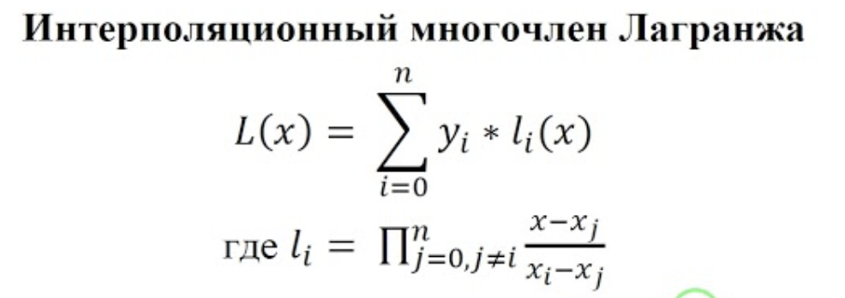

При помощи библиотеки отрисовываются подвижные точки. После каждого изменения графика точки пересчитываются по уравнению выше.

1. **Набор тестов**

1. Изначальный вид.

2. Перемещение точек.

3. Увеличение количества точек кривой.

4. Перемещение точек.

5. Увеличение количества точек кривой.

1. **Результаты выполнения тестов**

1. Изначальный вид.

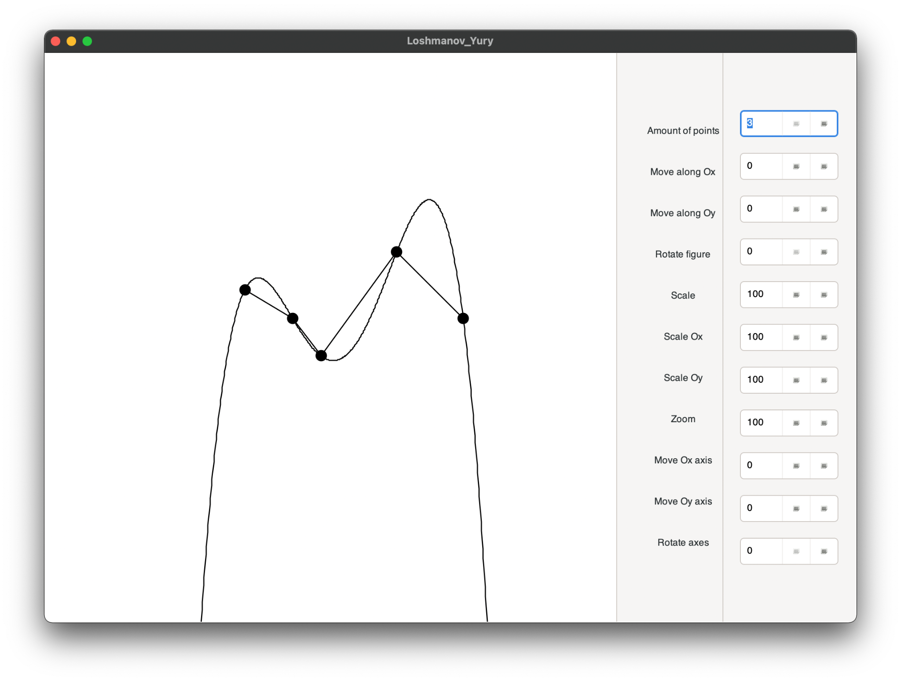

Рис. 4.1 Результат открытия окна

2. Перемещение точек.

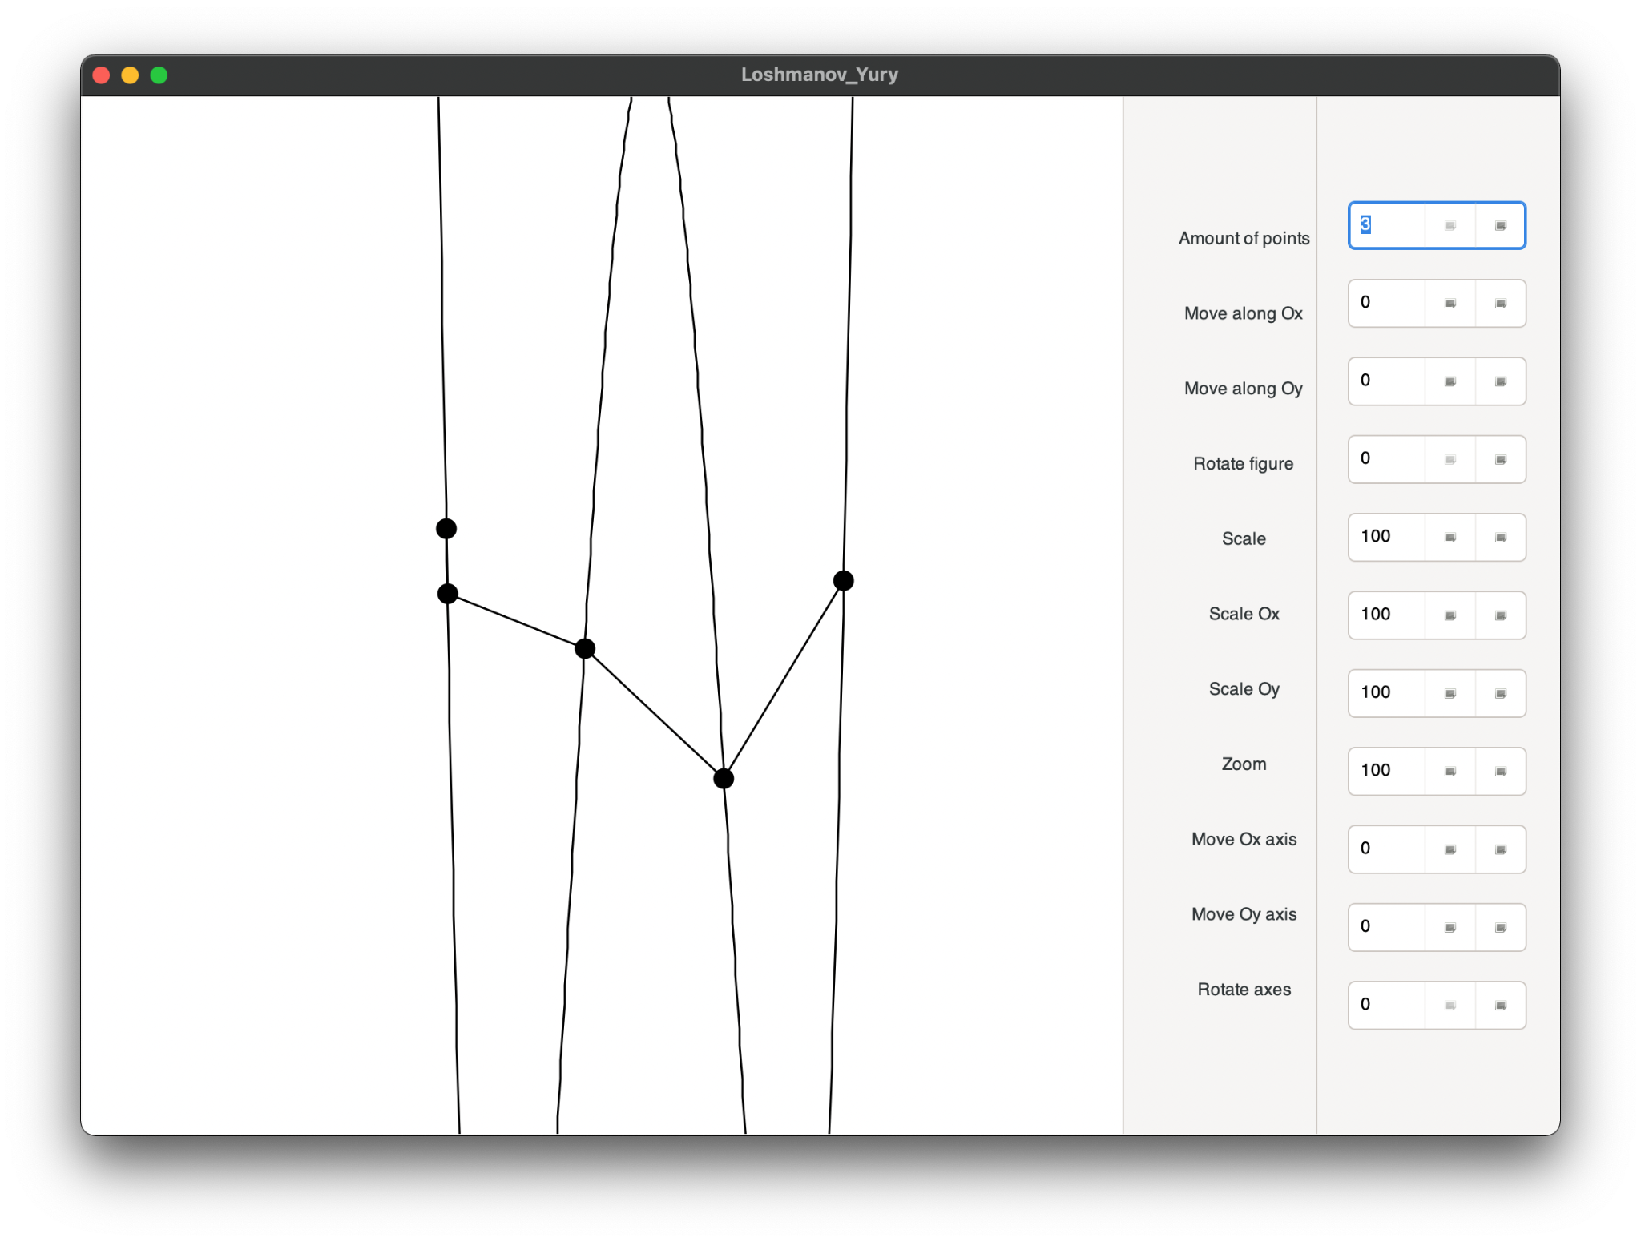

Рис. 4.2 Результат перемещение точек

3. Уменьшение количества точек.

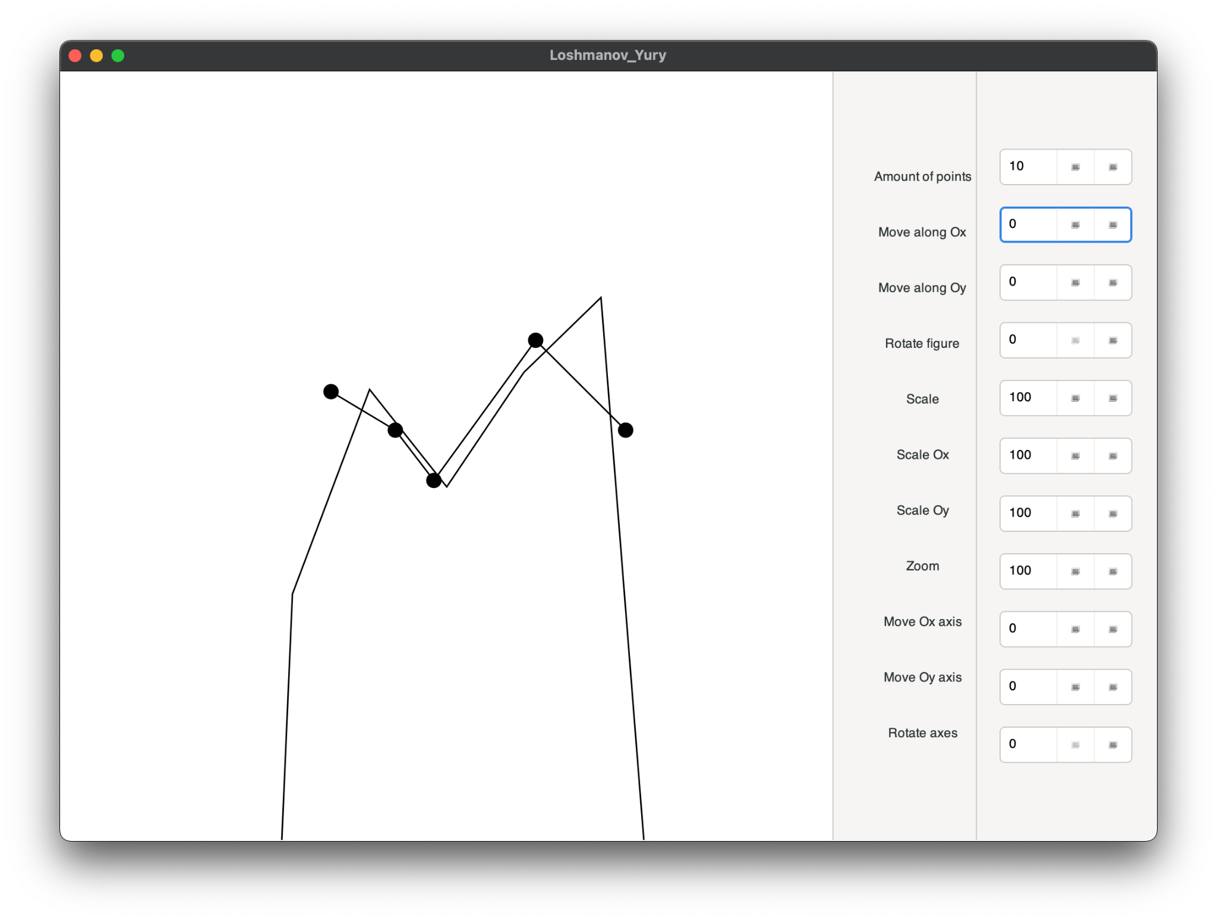

Рис. 4.3 Результат уменьшения количества точек

4. Перемещение точек.

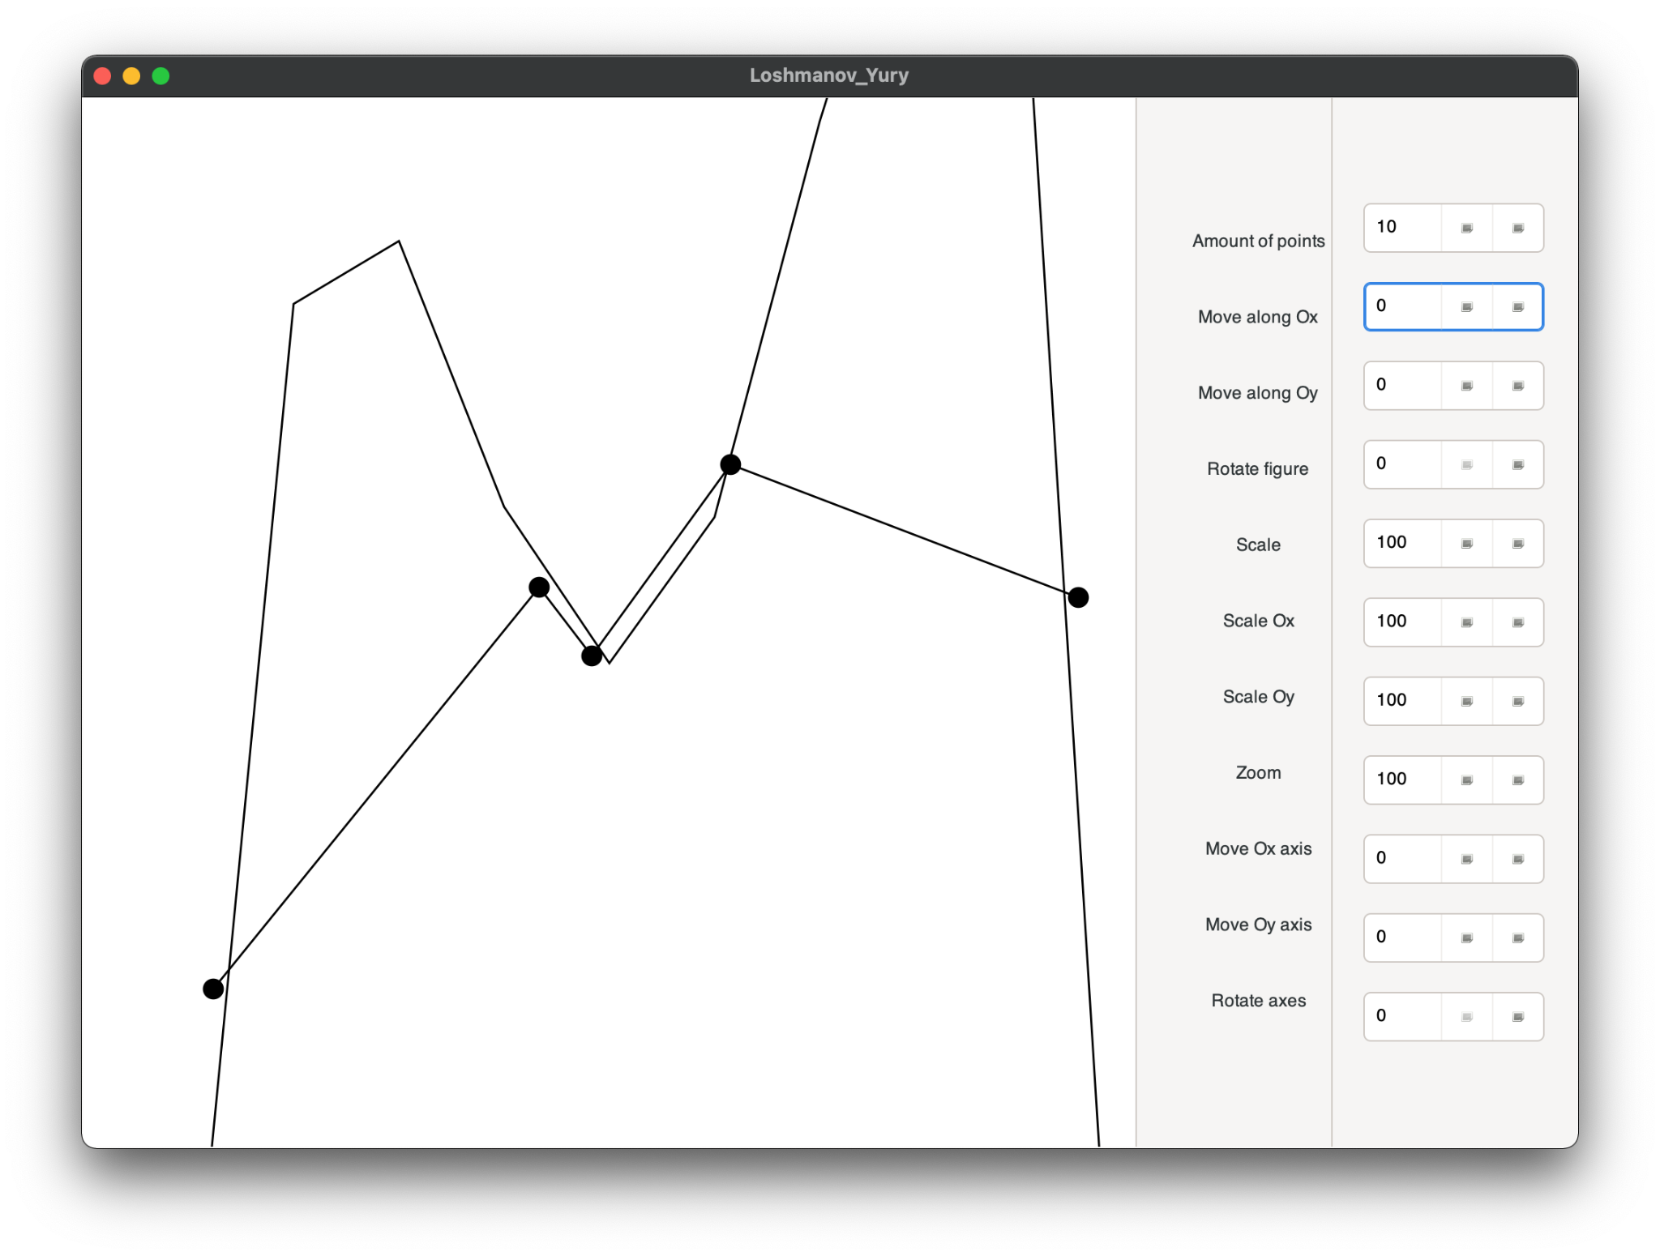

Рис. 4.4 Результат перемещения точек

5. Увеличение количества точек

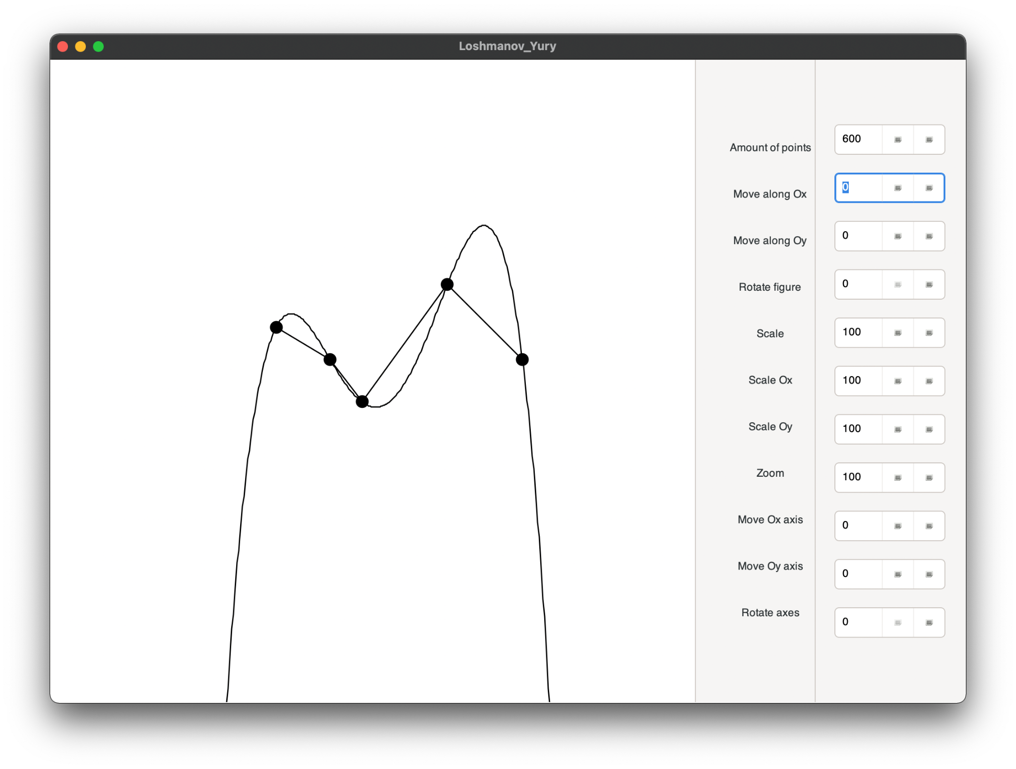

Рис. 4.5 Результат увеличения количества точек кривой

1. **Листинг программы**

**main.rs**

use gtk::prelude::*;

use gtk::Application;

use gio::prelude::*;

use std::collections::HashMap;

use std::env::args;

use std::rc::Rc;

use std::cell::RefCell;

use std;

mod canvas;

mod color;

mod figure;

mod point;

mod state;

mod buttons_events;

mod handle_draw;

use crate::figure::Figure;

use crate::canvas::{CairoCanvas, Canvas};

use crate::state::State;

use gdk::EventMask;

fn build_ui(app: &gtk::Application) {

// Initialize the UI with Glade XML.

let glade_src = include_str!("gui_lab1.glade");

let builder = gtk::Builder::from_string(glade_src);

// Get handles for the various controls we need to use.

let window: gtk::Window = builder.get_object("mainWindow")

.expect("Couldn't get mainWindow");

// Get handles for all the buttons.

let mut buttons: HashMap<String, gtk::SpinButton> = HashMap::new();

for name in &["cntPoints", "moveFigureOx", "moveFigureOy", "rotateFigure",

"scale", "scaleOx", "scaleOy",

"zoom", "moveAxisOx", "moveAxisOy", "rotateAxes"] {

buttons.insert(name.to_string(), builder.get_object(name)

.expect(&format!("Couldn't get button {}", name)));

}

let state = Rc::new(RefCell::new(State::new(&buttons)));

let drawing_area: gtk::DrawingArea = builder.get_object("drawingArea")

.expect("Couldn't get drawingArea");

let drawing = Rc::new(RefCell::new(drawing_area));

setup_canvas_area(&builder, &state, &drawing);

crate::buttons_events::setup_buttons_events(&buttons, &state, &drawing);

window.set_application(Some(app));

window.show_all();

}

fn setup_canvas_area(

builder: &gtk::Builder,

state: &Rc<RefCell<State>>,

drawing_area: &Rc<RefCell<gtk::DrawingArea>>,

) {

{

let draw_box: gtk::Box = builder.get_object("box").expect("Can't get boxx");

let draw_state = Rc::clone(&state);

let drawing = Rc::clone(&drawing_area);

drawing.borrow().connect_draw(move |_, cr| {

let size: (i32, i32) = (

draw_box.get_allocated_width(),

draw_box.get_allocated_height()

);

let mut canvas = CairoCanvas::new(&cr, size);

canvas.set_line_width(0.002);

let mut cur_draw_state = draw_state.borrow_mut();

let mut circle: Figure = Figure::new(&canvas);

crate::handle_draw::handle_draw(&mut canvas, &mut circle, &mut cur_draw_state);

Inhibit(false)

});

}

{

let drawing_area_cloned = Rc::clone(&drawing_area);

let drawing = drawing_area_cloned.borrow();

drawing.add_events(

EventMask::BUTTON_MOTION_MASK |

EventMask::BUTTON_PRESS_MASK |

EventMask::BUTTON_RELEASE_MASK

);

}

{

let button_state = Rc::clone(&state);

let drawing_area_cloned = Rc::clone(&drawing_area);

let drawing = drawing_area_cloned.borrow();

drawing.connect_button_press_event(move |_, event| {

let mut state = button_state.borrow_mut();

let (x, y) = event.get_position();

println!("({}, {})", x, y);

for i in 0..state.points.len() {

let px = state.points[i].x() *

state.zoom as f64 / 10.0 * state.coefficient +

(state.moveFigureOx + state.width / 2) as f64;

let py = -state.points[i].y() *

state.zoom as f64 / 10.0 * state.coefficient +

(state.moveFigureOy + state.height / 2) as f64;

println!("point ({}, {})", px, py);

if (px - x) * (px - x) + (py - y) * (py - y) <= 100.0 {

state.point_chosen_num = i as i32;

state.mouse_x = x;

state.mouse_y = y;

}

}

println!("state.numm {}", state.point_chosen_num);

Inhibit(false)

});

}

{

let button_state = Rc::clone(&state);

let drawing_area_cloned = Rc::clone(&drawing_area);

let drawing = drawing_area_cloned.borrow();

drawing.connect_button_release_event(move |area, _| {

let mut state = button_state.borrow_mut();

state.point_chosen_num = -1;

area.queue_draw();

Inhibit(false)

});

}

{

let button_state = Rc::clone(&state);

let drawing_area_cloned = Rc::clone(&drawing_area);

let drawing = drawing_area_cloned.borrow();

drawing.connect_motion_notify_event(move |area, event| {

let mut state = button_state.borrow_mut();

if state.point_chosen_num != -1 {

let (x, y) = event.get_position();

let id = state.point_chosen_num as usize;

state.points[id].x +=

(x - state.mouse_x) * 10.0 / state.zoom as f64 / state.coefficient;

state.points[id].y -=

(y - state.mouse_y) * 10.0 / state.zoom as f64 / state.coefficient;

state.mouse_x = x;

state.mouse_y = y;

println!("({}, {})", x, y);

}

area.queue_draw();

Inhibit(false)

});

}

}

fn main() {

// Initializing GTK application

let application = Application::new(

Some("src.main"),

gio::ApplicationFlags::NON_UNIQUE,

).expect("failed to initialize GTK application");

// The activation signal is emitted on the activation occurs

application.connect_activate(|app| build_ui(app));

// Run the application

application.run(&args().collect::<Vec<_>>());

}

**canvas.rs**

use crate::color::Color;

use crate::point::Point;

use std::cmp::min;

// A generic canvas trait

pub trait Canvas {

fn set_draw_color(&mut self, color: Color);

fn set_draw_color_alpha(&mut self, color: Color, alpha: f64);

fn set_line_width(&mut self, width: f64);

//fn text_size(&self, text: &str) -> Size;

fn print_text(&mut self, p: &Point, text: &str);

fn draw_line(&mut self, points: &[Point]);

fn draw_polygon(&mut self, points: &[Point]);

fn fill_polygon(&mut self, points: &[Point]);

fn width(&self) -> i32;

fn height(&self) -> i32;

}

pub struct CairoCanvas<'a> {

cr: &'a cairo::Context,

size: (i32, i32), // width and height (REDO on refactoring)

}

impl<'a> CairoCanvas<'a> {

pub fn new(cr: &'a cairo::Context, size: (i32, i32)) -> Self {

cr.scale(size.0 as f64, size.1 as f64);

cr.set_source_rgb(1.0, 1.0, 1.0);

cr.set_font_size(0.012);

cr.paint();

Self { cr, size }

}

}

// Wrapper for all line or shape drawing methods

// TODO: Add convert method

impl<'a> CairoCanvas<'a> {

pub fn make_path(&mut self, points: &[Point]) {

let (first, rest) = points

.split_first()

.expect("At least two points to make a line");

self.cr.move_to(first.x() as f64 / self.size.0 as f64,

first.y() as f64 / self.size.1 as f64);

for p in rest {

self.cr.line_to(p.x() as f64 / self.size.0 as f64,

p.y() as f64 / self.size.1 as f64);

}

}

pub fn draw_filled_circle(&mut self, point: &Point, radius: f64) {

let width = self.size.0 as f64;

let height = self.size.1 as f64;

let x = point.x() as f64 / width;

let y = point.y() as f64 / height;

let coeff = min(self.size.0, self.size.1) as f64 / 600.0;

self.cr.arc(x, y, radius * coeff / 600.0,

0.0,

2.0 * std::f64::consts::PI);

self.cr.fill();

self.cr.stroke();

}

}

impl<'a> Canvas for CairoCanvas<'a> {

fn set_draw_color(&mut self, color: Color) {

self.cr.set_source_rgb(color.r() as f64 / 255.0,

color.g() as f64 / 255.0,

color.b() as f64 / 255.0)

}

fn set_draw_color_alpha(&mut self, color: Color, alpha: f64) {

self.cr.set_source_rgba(

color.r() as f64 / 255.0,

color.g() as f64 / 255.0,

color.b() as f64 / 255.0,

alpha,

)

}

fn set_line_width(&mut self, width: f64) {

self.cr.set_line_width(width);

}

fn print_text(&mut self, p: &Point, text: &str) {

self.cr.move_to(p.x() as f64 / self.size.0 as f64,

p.y() as f64 / self.size.1 as f64);

self.cr.show_text(text);

//self.cr.select_font_face("Sans", FontSlant::Normal, FontWeight::Normal);

//self.cr.set_font_size(0.35);

//self.cr.move_to(0.04, 0.53);

//self.cr.show_text("Hello");

}

fn draw_line(&mut self, points: &[Point]) {

if points.len() > 1 {

self.make_path(points);

self.cr.stroke();

}

}

fn draw_polygon(&mut self, points: &[Point]) {

if points.len() > 1 {

self.make_path(points);

self.cr.close_path();

self.cr.stroke();

}

}

fn fill_polygon(&mut self, points: &[Point]) {

if points.len() > 1 {

self.make_path(points);

self.cr.close_path();

self.cr.fill_preserve();

self.cr.stroke();

}

}

fn width(&self) -> i32 {

self.size.0

}

fn height(&self) -> i32 {

self.size.1

}

}

**state.rs**

use std::collections::HashMap;

use gtk::prelude::*;

use crate::point::Point_f64;

use std::vec::Vec;

// Shared state for communication between buttons and drawingarea

pub struct State {

pub points: Vec<Point_f64>,

pub cntPoints: i32,

pub moveFigureOx: i32,

pub moveFigureOy: i32,

pub scale: i32,

pub scaleOx: i32,

pub scaleOy: i32,

pub zoom: i32,

pub moveAxisOx: i32,

pub moveAxisOy: i32,

pub rotateAxes: i32,

pub point_chosen_num: i32,

pub coefficient: f64,

pub width: i32,

pub height: i32,

pub mouse_x: f64,

pub mouse_y: f64,

}

// And i really sorry about camel case

fn default_points() -> Vec<Point_f64> {

vec![

Point_f64::new(-9.0, 5.0),

Point_f64::new(-4.0, 2.0),

Point_f64::new(-1.0, -2.0),

Point_f64::new(7.0, 9.0),

Point_f64::new(14.0, 2.0),

]

}

impl State {

pub fn new(buttons: &HashMap<String, gtk::SpinButton>) -> Self {

State {

points: default_points(),

cntPoints: 1000, //buttons.get("cntPoints").unwrap().get_value_as_int(),

moveFigureOx: buttons.get("moveFigureOx").unwrap().get_value_as_int(),

moveFigureOy: buttons.get("moveFigureOy").unwrap().get_value_as_int(),

scale: buttons.get("scale").unwrap().get_value_as_int(),

scaleOx: buttons.get("scaleOx").unwrap().get_value_as_int(),

scaleOy: buttons.get("scaleOy").unwrap().get_value_as_int(),

zoom: buttons.get("zoom").unwrap().get_value_as_int(),

moveAxisOx: buttons.get("moveAxisOx").unwrap().get_value_as_int(),

moveAxisOy: buttons.get("moveAxisOy").unwrap().get_value_as_int(),

rotateAxes: buttons.get("rotateAxes").unwrap().get_value_as_int(),

point_chosen_num: -1,

coefficient: 1.0,

width: 0,

height: 0,

mouse_x: 0.0,

mouse_y: 0.0,

}

}

}

**figure.rs**

use crate::point::{self, Point, Point_f64};

use crate::color::Color;

use std::f64::consts::PI;

use crate::canvas::{CairoCanvas, Canvas};

struct Axis {

xoy: Point,

angle: f64,

zoom: u32,

real_zoom: f64,

center: Point,

}

impl<'a> Axis {

pub fn new(canvas: &'a CairoCanvas) -> Self {

Axis {

xoy: Point::new(

canvas.width() / 2,

canvas.height() / 2,

),

angle: 0.0,

zoom: 100,

real_zoom: 1.0,

center: Point::new(

canvas.width() / 2,

canvas.height() / 2,

),

}

}

pub fn rotate(&mut self, angle: f64) {

self.angle = to_radians(angle);

}

pub fn zoom(&mut self, zoom: u32) {

self.zoom = zoom;

self.real_zoom = 2_f64.powi(100 - self.zoom as i32);

}

pub fn shift(&mut self, offset: Point) {

self.xoy = self.center + offset;

}

pub fn draw(&self, canvas: &mut CairoCanvas) {

let diagonal = ((canvas.width() * canvas.width()

+ canvas.height() * canvas.height()) as f64)

.sqrt()

* 2.0;

let a = Point::new(

self.xoy.x() + (diagonal * self.angle.cos()) as i32,

self.xoy.y() + (diagonal * self.angle.sin()) as i32,

);

let b = Point::new(

self.xoy.x() + (diagonal * (self.angle + PI * 0.5).cos()) as i32,

self.xoy.y() + (diagonal * (self.angle + PI * 0.5).sin()) as i32,

);

let c = Point::new(

self.xoy.x() + (diagonal * (self.angle + PI).cos()) as i32,

self.xoy.y() + (diagonal * (self.angle + PI).sin()) as i32,

);

let d = Point::new(

self.xoy.x() + (diagonal * (self.angle + PI * 1.5).cos()) as i32,

self.xoy.y() + (diagonal * (self.angle + PI * 1.5).sin()) as i32,

);

self.draw_strokes(canvas);

// Find intersection with borders

// let = point::intersect_rect_line(&self.corner, (&a, &c));

// let [b, d] = point::intersect_rect_line(&self.corner, (&b, &d));

canvas.draw_line(&[a, c]);

canvas.draw_line(&[b, d]);

}

fn draw_strokes(&self, canvas: &mut CairoCanvas) {

const MAG: u32 = 100;

let step = MAG;// - (MAG / 2) * self.zoom % MAG;

let astep = Point_f64::new(

step as f64 * self.angle.cos(),

step as f64 * self.angle.sin()

);

let bstep = Point_f64::new(

step as f64 * (PI * 0.5 + self.angle).cos(),

step as f64 * (PI * 0.5 + self.angle).sin(),

);

const STROKE_LEN: f64 = 4.0;

let aperp = Point_f64::new(

STROKE_LEN * (PI * 0.5 + self.angle).cos(),

STROKE_LEN * (PI * 0.5 + self.angle).sin(),

);

let bperp = Point_f64::new(

STROKE_LEN * (PI * 1.0 + self.angle).cos(),

STROKE_LEN * (PI * 1.0 + self.angle).sin(),

);

let pt: Point_f64 = Point_f64::from(self.xoy.clone());

let lu = Point_f64::new(0.0, 0.0);

let rd = Point_f64::new(

canvas.width() as f64,

canvas.height() as f64,

);

// GoGo paint it out!

let apt = self.draw_axis(canvas, pt, astep, aperp, lu, rd, 1.0);

let apt = self.point_arrow(apt - astep, apt, lu, rd);

canvas.draw_line(&[

Point::from(apt + bperp * 2.0 + aperp),

Point::from(apt),

]);

canvas.draw_line(&[

Point::from(apt + bperp * 2.0 - aperp),

Point::from(apt),

]);

self.draw_axis(canvas, pt, -astep, aperp, lu, rd, -1.0);

self.draw_axis(canvas, pt, bstep, bperp, lu, rd, -1.0);

let bpt = self.draw_axis(canvas, pt, -bstep, bperp, lu, rd, 1.0);

let bpt = self.point_arrow(bpt + bstep, bpt, lu, rd);

canvas.draw_line(&[

Point::from(bpt + aperp * 2.0 + bperp),

Point::from(bpt),

]);

canvas.draw_line(&[

Point::from(bpt + aperp * 2.0 - bperp),

Point::from(bpt),

]);

}

fn draw_axis(&self, canvas: &mut CairoCanvas,

pt: Point_f64, step: Point_f64, perp: Point_f64,

lu: Point_f64, rd: Point_f64, sign: f64

) -> Point_f64 {

let mut pt = pt;

let num = 100.0 / 2_f64.powi(100 - self.zoom as i32);

for i in 1..40 {

pt = pt + step;

if !point::is_in_rectangle(lu, rd, pt) {

break;

}

canvas.draw_line(&[ Point::from(pt + perp), Point::from(pt - perp) ]);

canvas.print_text(&Point::from(pt + perp * 4.0),

&(format!("{:.1}", sign * (i as f64 * num))));

}

pt

}

fn point_arrow(&self, pre_pt: Point_f64, pt: Point_f64,

lu: Point_f64, rd: Point_f64) -> Point_f64 {

let mut l = pre_pt;

let mut r = pt;

const EPS: f64 = 0.001;

while (r - l).x().abs() > EPS || (r - l).y().abs() > EPS {

let mid = (l + r) * 0.5;

if !point::is_in_rectangle(lu, rd, mid) {

r = mid;

} else {

l = mid;

}

}

r

}

}

pub struct Figure {

points: Vec<Point_f64>, // точки, по которым строим окружность

base_points: Vec<Point_f64>,

axis: Axis, // абсциссы, к которым привязана фигура

offset: Point, // сдвиг к центру

parts: u32, // количество точек, по которым строится фигура

scale_ox: f64,

scale_oy: f64,

zoom: f64,

}

fn to_radians(angle: f64) -> f64 {

angle / 180.0 * PI

}

fn points_to_i32(pts_f64: &Vec<Point_f64>) -> Vec<Point> {

let mut pts_i32: Vec<Point> = Vec::new();

for pt in pts_f64 {

pts_i32.push(Point::new(pt.x() as i32, pt.y() as i32));

}

pts_i32

}

impl Figure {

pub fn new(canvas: &CairoCanvas) -> Self {

Figure {

points: Vec::new(),

base_points: Vec::new(),

axis: Axis::new(&canvas),

offset: Point::new(0, 0),

parts: 0u32,

scale_ox: 100f64,

scale_oy: 100f64,

zoom: 0.0,

}

}

pub fn set_base_points(&mut self, pts: &Vec<Point_f64>) {

self.base_points = pts.clone();

}

pub fn parts(&mut self, parts: u32) {

self.parts = parts;

}

pub fn rotate_axis(&mut self, angle: f64) {

self.axis.rotate(angle);

}

pub fn shift_axis(&mut self, offset: Point) {

self.axis.shift(offset);

}

pub fn zoom(&mut self, zoom: f64) {

//self.axis.zoom(zoom as u32);

self.zoom = zoom;

}

pub fn shift(&mut self, offset: Point) {

self.offset = offset;

}

pub fn scaleOx(&mut self, scale: f64) {

self.scale_ox = scale;

}

pub fn scaleOy(&mut self, scale: f64) {

self.scale_oy = scale;

}

fn lagrange(&self, x: f64) -> f64 {

let mut y: f64 = 0.0;

for i in 0..self.base_points.len() {

let mut l_up: f64 = 1.0;

let mut l_down: f64 = 1.0;

for j in 0..self.base_points.len() {

if i != j {

l_up *= x - self.base_points[j].x();

l_down *= self.base_points[i].x() - self.base_points[j].x();

}

}

y += l_up / l_down * self.base_points[i].y();

}

y

}

fn construct(&mut self, canvas: &mut CairoCanvas) {

let begin: f64 = 0.0;

let end: f64 = canvas.width() as f64;

let width = end - begin;

let step = width / (self.parts as f64);

//println!("begin = {}, end = {}, steep = {}", begin, end, step);

for num in 0..=self.parts {

let x = begin + step * num as f64;

if x > begin + width {

break

}

self.points.push(Point_f64::new(x, self.lagrange(x)));

//println!("x = {}", x);

}

}

fn transform_points(&self, pts_f64: &Vec<Point_f64>) -> Vec<Point_f64> {

let mut pts_i32: Vec<Point_f64> = Vec::new();

for pt in pts_f64 {

let new_pt = Point_f64::new(pt.x(), -pt.y()) * self.zoom +

Point_f64::from(self.offset);

pts_i32.push(new_pt);

println!("{:?} -> {:?}", pt, pts_i32.last());

}

pts_i32

}

pub fn draw(&mut self, canvas: &mut CairoCanvas) {

canvas.set_draw_color(Color::new(0, 0, 0));

self.points = self.transform_points(&self.points);

self.base_points = self.transform_points(&self.base_points);

self.construct(canvas);

canvas.draw_line(&points_to_i32(&self.points));

canvas.draw_line(&points_to_i32(&self.base_points));

for pt in &points_to_i32(&self.base_points) {

canvas.draw_filled_circle(pt, 5.0);

}

//self.axis.draw(canvas);

}

}

1. **Выводы**

Выполнив данную лабораторную работу, я закрепил знания по использованию и запуску графического интерфейса, перерисовыванию его в зависимости от изменения окна и отрисовки полиномиальной кривой. Также улучшил свои навыки с отображением интерактивной 2D графики. Также научился делать сложные построения кривых по заданным точкам.

**ЛИТЕРАТУРА**

1. Интерполяция данных / Хабр [Электронный ресурс]URL: <https://habr.com/ru/post/264191/> (Дата обращения: 25.11.2021).

2. Применение сегментированной кубической кривой [Электронный ресурс]URL: <https://russianblogs.com/article/2306554689/> (Дата обращения: 25.11.2021).

3. Cubic Hermite spline [Электронный ресурс]URL: <https://en.wikipedia.org/wiki/Cubic_Hermite_spline> (Дата обращения: 26.11.2021).